HOME PAGE
Curated classics. Timeless reading.
Discover timeless classics from the world's greatest authors.
Free, forever.

Click here to browse our free ebooks


Featured Classics
Handpicked literary masterpieces

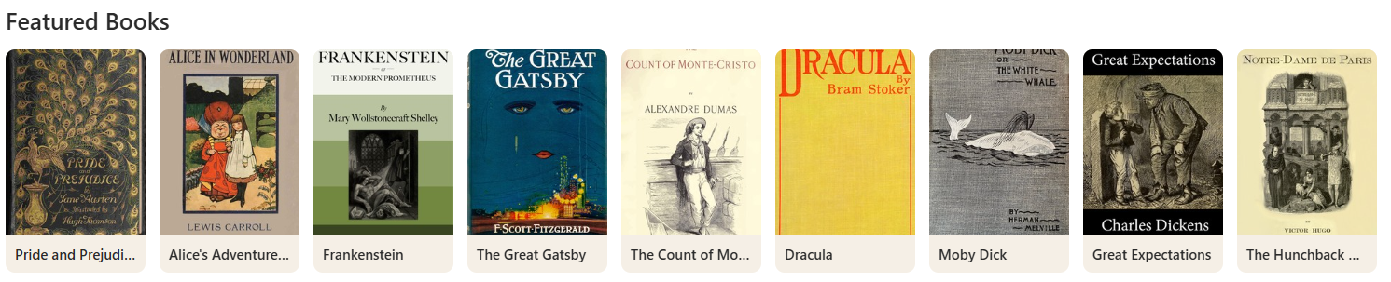

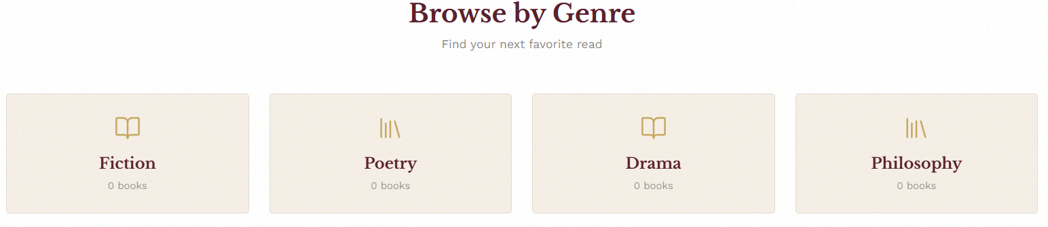
SOCIAL HANDLES

